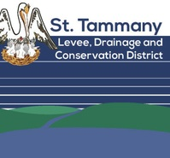
ST. TAMMANY LEVEE,
DRAINAGE AND CONSERVATION DISTRICT
FINANCE COMMITTEE MEETING

Wednesday, March 16, 2022
5:00 P.M.
Slidell City Auditorium,
2056 Second Street, Slidell, LA 70471

AGENDA

- Welcome and Call to Order
- Roll Call
- Finance Discussion
- Adjournment

